**Project: Student Database Management System(PostgreSQL)** *1. Database Setup Create a database named "student_database."*

CREATE DATABASE student_database;

*Create a table called " student_table " with the following columns: Student_id (integer), Stu_name (text), Department (text), email_id (text ),Phone_no (numeric), Address (text), Date_of_birth (date), Gender (text), Major (text), GPA (numeric),Grade (text) should be A,B,C etc.*

CREATE TABLE student_table (Student_id INTEGER PRIMARY KEY,  
Stu_name TEXT,  
Department TEXT,  
email_id TEXT,  
Phone_no NUMERIC,  
Address TEXT,  
Date_of_birth DATE,  
Gender TEXT,  
Major TEXT,  
GPA NUMERIC,  
Grade TEXT CHECK (Grade IN ('A', 'B', 'C', 'D', 'F')));

*2. Data Entry  
Insert 10 sample records into the "student_table" using INSERT command.*

INSERT INTO student_table (Student_id, Stu_name, Department, email_id, Phone_no, Address, Date_of_birth, Gender, Major, GPA, Grade)  
VALUES (1, 'Sachin Tendulkar', 'Sports', 'srt.god@email.com', 9874563456, '33 Desert Storm Rd', '2000-03-12', 'Male', 'Cricker', 4.8, 'A'),  
(2, 'Salman Khan', 'Fine Arts', 'black.buck@email.com', 9420420420, '428 Driver Rd', '1998-03-13', 'Male', 'Acting', 2.7, 'C'),  
(3, 'Deepika Padukone', 'Fine Arts', 'imranveer@email.com', 9143143143, '297 Ranveer St', '2001-08-29', 'Female', 'Acting', 3.5, 'B'),  
(4, 'Sunil Chetri', 'Sports', 'captain.leader@email.com', 3478213210, '241 Legend Rd', '1998-04-24', 'Male', 'Football', 4.5, 'A'),  
(5, 'Nirmala Sitharaman', 'Politics', 'more.tax@email.com', 9678456766, '276 Finance Rd', '2000-09-01', 'Female', 'Finance', 3.2, 'B'),  
(6, 'Narendra Modi', 'Politics', 'prime.minister@email.com', 9653876410, '313 King Rd', '1998-06-16', 'Male', 'Socials', 2.5, 'D'),  
(7, 'Smriti Mandana', 'Sports', 'number.18@email.com', 9874675432, '864 Willow Rd', '1999-02-09', 'Female', 'Cricket', 3.9, 'A'),  
(8, 'Gautham Adani', 'Business', 'modi.zindabad@email.com', 9845673459, '241 Port Rd', '2001-01-01', 'Male', 'Enterprise', 2.6, 'C'),  
(9, 'Mukesh Ambani', 'Business', 'reliance.king@email.com', 9870456526, '111 Antilla Rd', '2001-06-19', 'Male', 'Telecom', 4.7, 'A'),  
(10, 'Sundar Pichai', 'Business', 'googol.chrome@email.com', 9876573456, '132 America Rd', '2000-11-21', 'Male', 'Software', 1.8, 'F');

*3. Student Information Retrieval  
Develop a query to retrieve all students' information from the "student_table" and sort them in descending order by their grade.*

SELECT * FROM student_table ORDER BY Grade DESC;

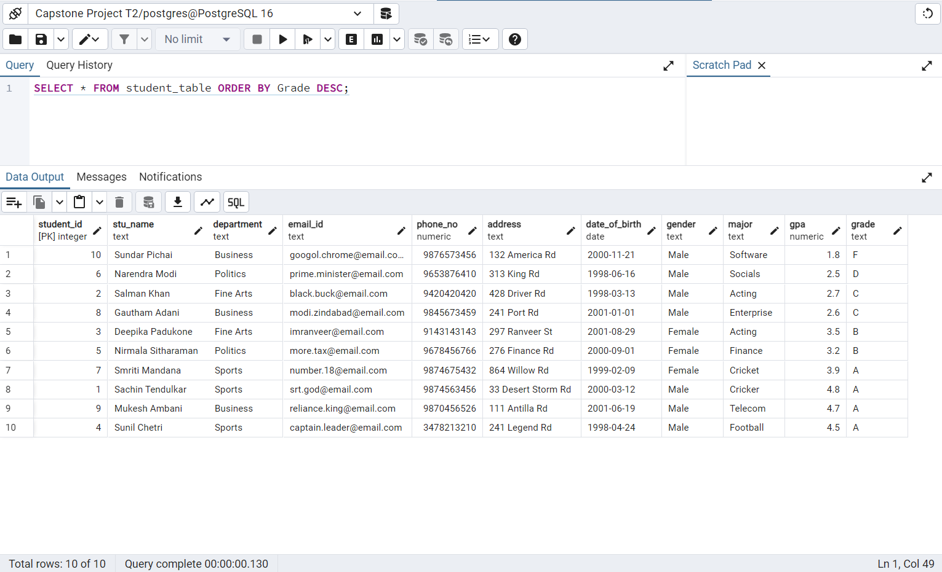

*4. Query for Male Students:  
Implement a query to retrieve information about all male students from the "student_table."*

SELECT * FROM student_table WHERE Gender = 'Male';

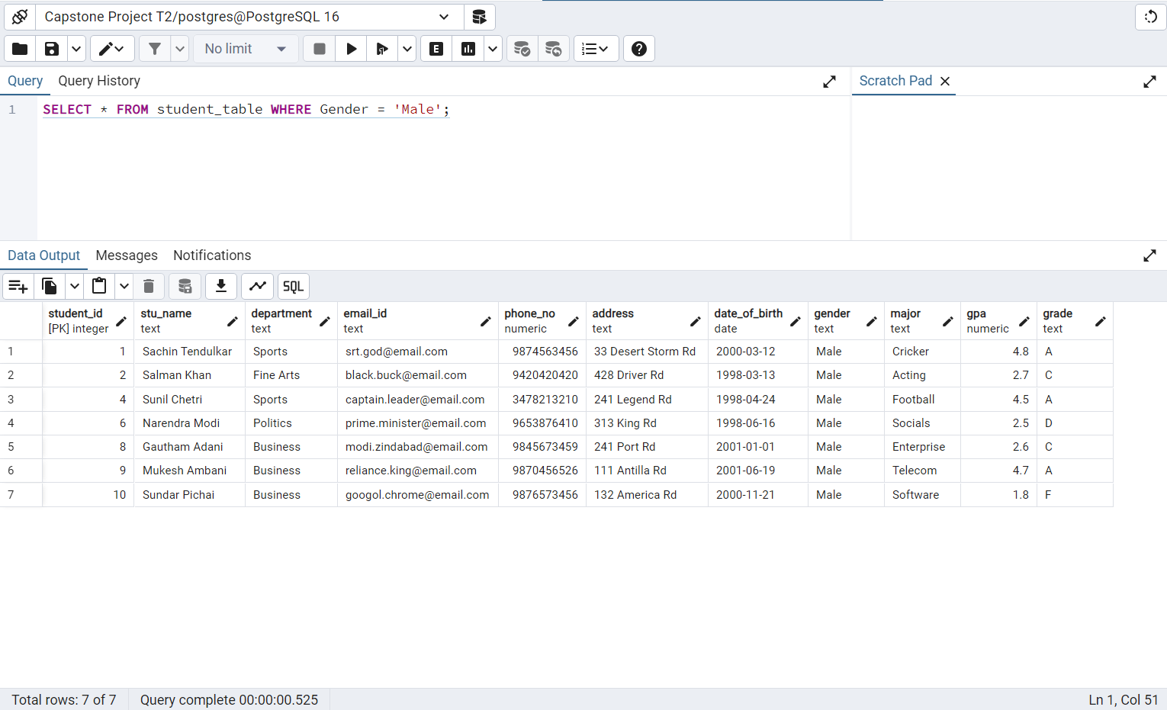

*5. Query for Students with GPA less than 5.0  
Create a query to fetch the details of students who have a GPA less than 5.0 from the "student_table."*

SELECT * FROM student_table WHERE GPA < 5.0;

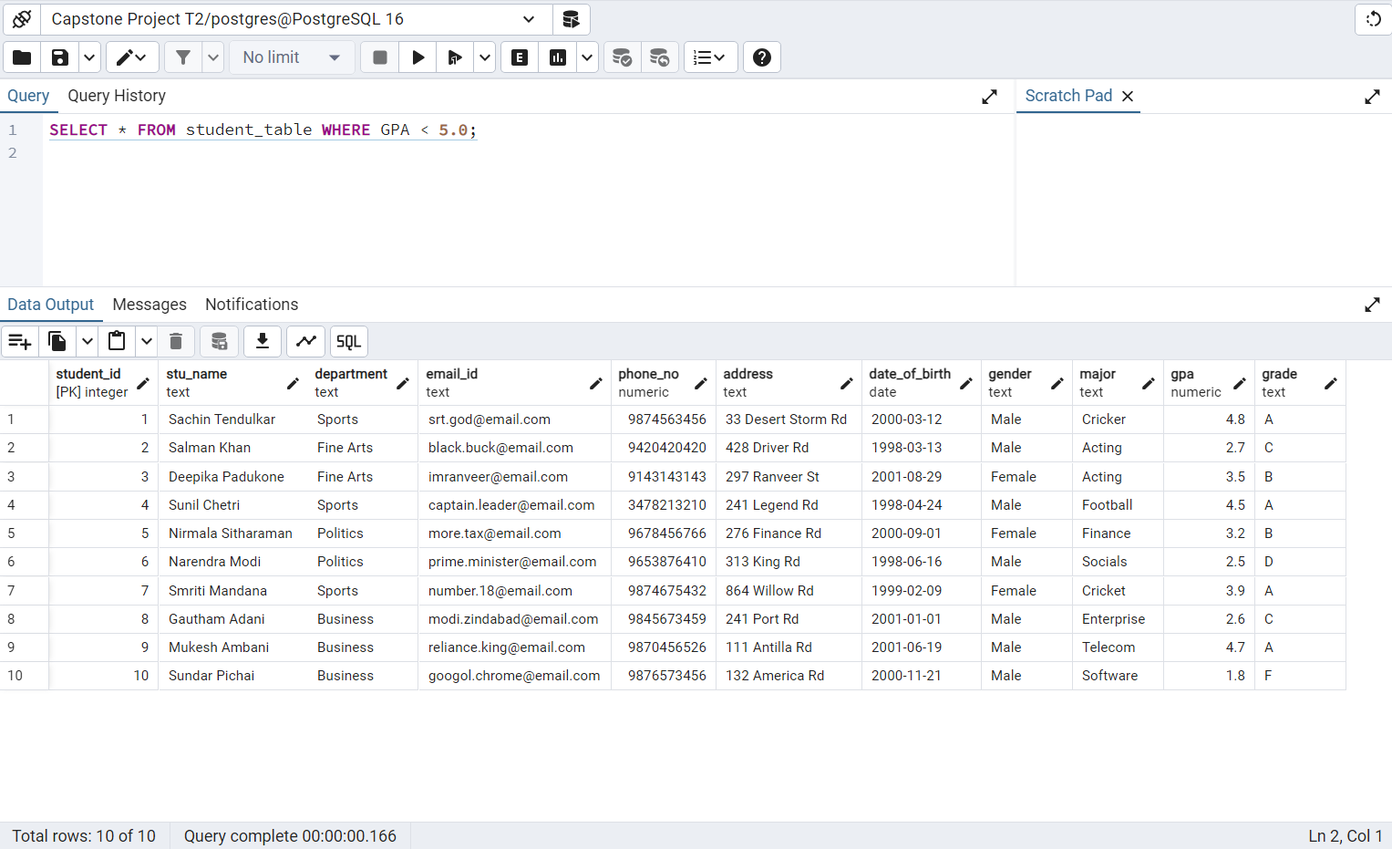

*6. Update Student Email and Grade  
Write an update statement to modify the email and grade of a student with a specific ID in the "student_table."*

UPDATE student_table SET email_id = 'srt.legend@example.com', Grade = 'B'  
WHERE Student_id = 1;

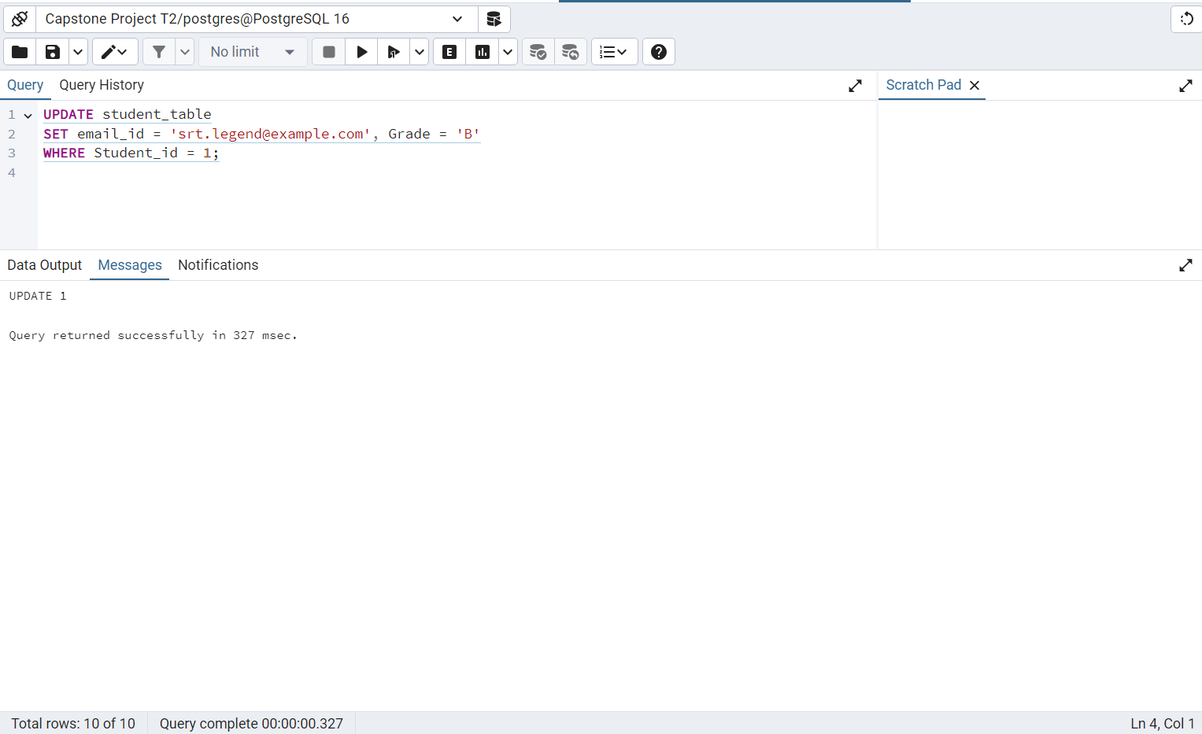

*7. Query for Students with Grade "B"  
Develop a query to retrieve the names and ages of all students who have a grade of "B" from the "student_table."*

SELECT Stu_name, DATE_PART('year', AGE(Date_of_birth)) AS Age FROM student_table  
WHERE Grade = 'B';

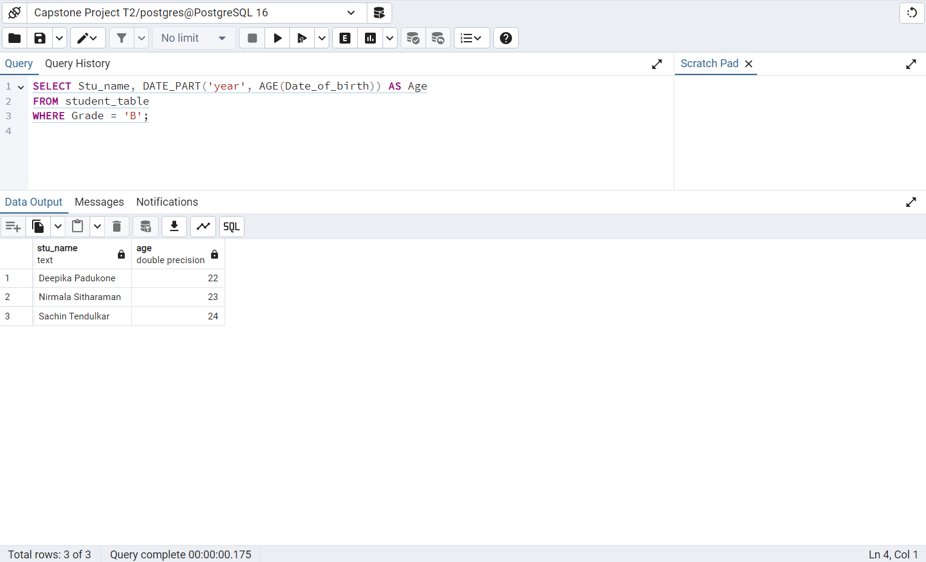

*8. Grouping and Calculation  
Create a query to group the "student_table" by the "Department" and "Gender" columns and calculate the average GPA for each combination.*

SELECT Department, Gender, AVG(GPA) AS Average_GPA FROM student_table  
GROUP BY Department, Gender;

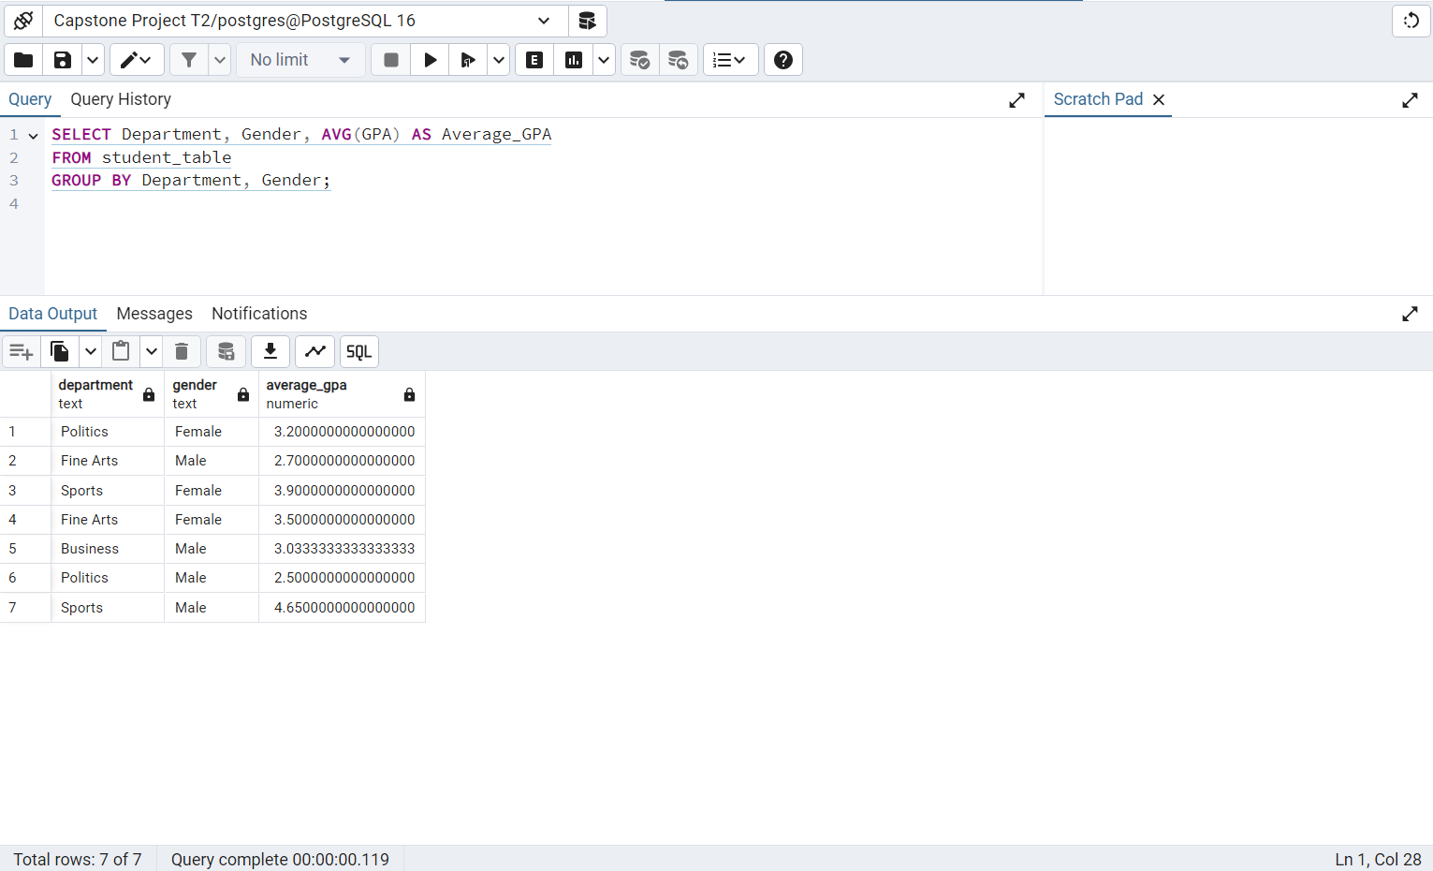

*9. Table Renaming  
Rename the "student_table" to "student_info" using the appropriate SQL statement.*

ALTER TABLE student_table RENAME TO student_info;

*10. Retrieve Student with Highest GPA  
Write a query to retrieve the name of the student with the highest GPA from the "student_info" table.*

SELECT Stu_name FROM student_info  
ORDER BY GPA DESC  
LIMIT 1;

